VIETNAM NATIONAL UNIVERSITY – HOCHIMINH CITY THE INTERNATIONAL UNIVERSITY

SCHOOL OF COMPUTER SCIENCE AND ENGINEERING



**USING VOICE TO MONITOR LIGHTS BASE ON GOOGLE ASSISTANT**

Name:

* Phan Nguyen Huy Hoang
* Tran Gia Phu

# TABLE OF CONTENTS

ACKNOWLEGMENTS iii

TABLE OF CONTENTS iv

LIST OF FIGURES vi

LIST OF TABLES viii

LIST OF ABBREVIATIONS ix

CHAPTER 1: INTRODUCTION 4

* 1. Overview 4
  2. Structure of Thesis 4
  3. Hardware Platform 4
     1. NodeMCU Board (ESP8266 Module Wi-Fi) 4
     2. Infrared light-emitting diode (IR LED) 5
     3. Relay 5
  4. Overall Framework of this research 6
  5. Phase 1: Application Interfaces 7
  6. Phrase 2: Cloud Services 8
     1. Adafruit IO 8
     2. IFTTT 12

CHAPTER 2 : RESULT………………………………………………………………..16

# LIST OF ABBREVIATIONS

|  |  |
| --- | --- |
| ERD HVAC  I/O  IDE | Entity Relationship Diagram  Heating, ventilation, and air conditioning Input and Output  Integrated Development Environment |
| IFTTT | If This Then That |
| iOS | Operating System for Apple Product |
| IoT | Internet of Things |
| IP | Internet Protocol |
| LDR | Light-Dependent Resistor |
| MQTT | Message Queue Telemetry Transport |
| NFC | Near Field Communication |
| OS | Operating System |
| PWM | Pulse Width Modulation |
| RAM | Random-Access Memory |
| SOC | System on Chip |
| TCP | Transmission Control Protocol |

# CHAPTER 1: METHODOLOGY

# Overview

This project introduces the way to build a system which controls lights through voice base on google assistant.

* 1. **Structure of thesis**

The structure of my thesis is as described in the following:

* + - Chapter 1 overview and presents the methodology of my proposed voice data mining to control, monitor, and keep track of the indoor devices
    - Chapter 2 demonstrates the testing results

# Hardware Platform

2.1.1. NodeMCU Board (ESP8266 Module Wi-Fi)

ESP8266 is a Wi-Fi module for wireless connection [13]. It provide the user with a full Wi-Fi networking solution without requiring more additional installment of devices and application. Moreover, it can be applied in migration of wifi networking functions between processors. The most common library is ESP8266 Wi-Fi which offers many implementation examples like WiFiClient, WiFiServer, WiFiAccessPoint, and etc. [14].

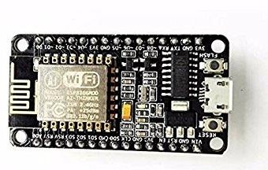

*Figure 7. NodeMCU*

* + 1. Infrared light**-**emitting diode **(**IR LED**)**

Infrared light-emitting diode emits infrared light, which means it emits light in the infrared frequency range. We cannot see the infrared light with our eyes, it is invisible to the human eye. Infrared wavelength is about 700nm - 1mm [20]. Everything creates heat which cause to emit infrared like the human body. Infrared has the same characteristic as visible light, as it can be focused, reflected and polarized as visible light.

Unlike invisible infrared light, the IR LED looks like a normal LED and also plays as a conventional LED, which means that it consumes electricity which is 20mA and 3vots. Infrared LEDs have an approximate illumination angle of 20-60 degrees with the range of a few centimeters to several feets [21], depending on the type of IR transmitter and manufacturer. Some of transmitters have the range of a few kilometers.

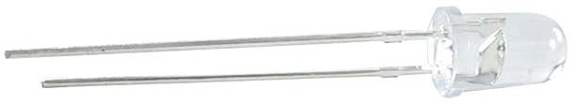

*Figure 11. IR Led.*

* + 1. Relay

A relay is usually an electromechanical device that is activated by electric currents [22]. Relay is like a remote control switch which is used in many applications in industry because of relative simplicity, long service life and proven reliability [23]. Relays are used in many different applications throughout the industry, such as in telephone exchange, digital computers and automation systems. Highly complex relay is used to protect electrical systems against breakdowns and power outages as well as to regulate and control the generation and distribution of electricity [24]. In the houses, the relay is used in

refrigerators, washing machines and dishwashers, and thermostats and air conditioners [25].

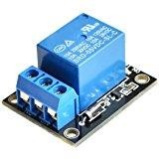

*Figure 12. Relay component.*

Although relays are often combined with circuits, there are many other types, such as pneumatics and hydraulics [26]. The input signal can be either direct or indirect electrical parameters or outputs. Relay works with electrical operation. Many relays use electromagnetic switches to operate. Relays are very useful for controlling the circuit by low power signal. Electricity flows through the coil and generates a magnetic field and changes the contact of the switch. Current in the coil can be turned on / off so that relays with two switching positions are switch contacts. The relay allows one circuit to be completely separated from the other circuit that is previously connected to it.

# Overall Framework of this research

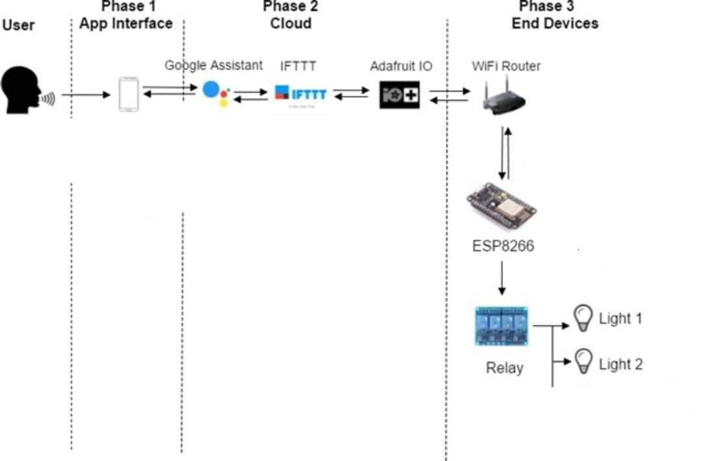User commit communication via android/iOS application, which is used for the voice recognition platform enabling simple access. Moreover, NodeMCU has been utilized as a microcontroller with switching circuit and Wi-Fi module for remote access. Based on [1], I build the system model in Figure 13.

*Figure 13. Methodology implemented for development of the system.*

# Phase 1: Application Interfaces

This section will show how to install the Google Assistant Application for each environment at section 3.3.1 and section 3.3.2.

* + 1. On smart devices For iOS:
       1. iPhone or iPad with the version 10 or higher
       2. Device's language set to English language.
       3. Google Assistant application. For android:
       4. Version 5.0 or higher.
       5. 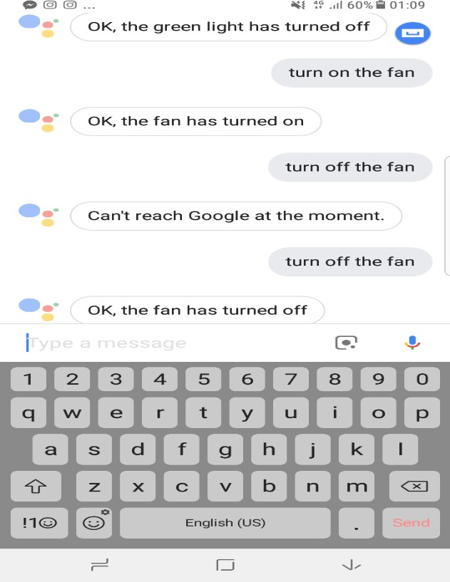Device's language set to English language.

*Figure 15. Google Assistant App on smart devices.*

# Phrase 2: Cloud Services

* + 1. Adafruit IO

Adafruit IO [29] is a system that makes data useful. This is an IOT platform built using the Message Queue Telemetry Transport (MQTT). The cloud database will be receive the message signal string from these applet which discuss in section 3.4.2 and store them. After that, the ESP8266 will read signal change which discuss on section 3.5.

# The Feeds tab:

Clicking on the Actions drop-down menu, and creating a new feed “onoff”, “r1onoff” , “r2onoff” , “r3onoff” , “r5onoff”.

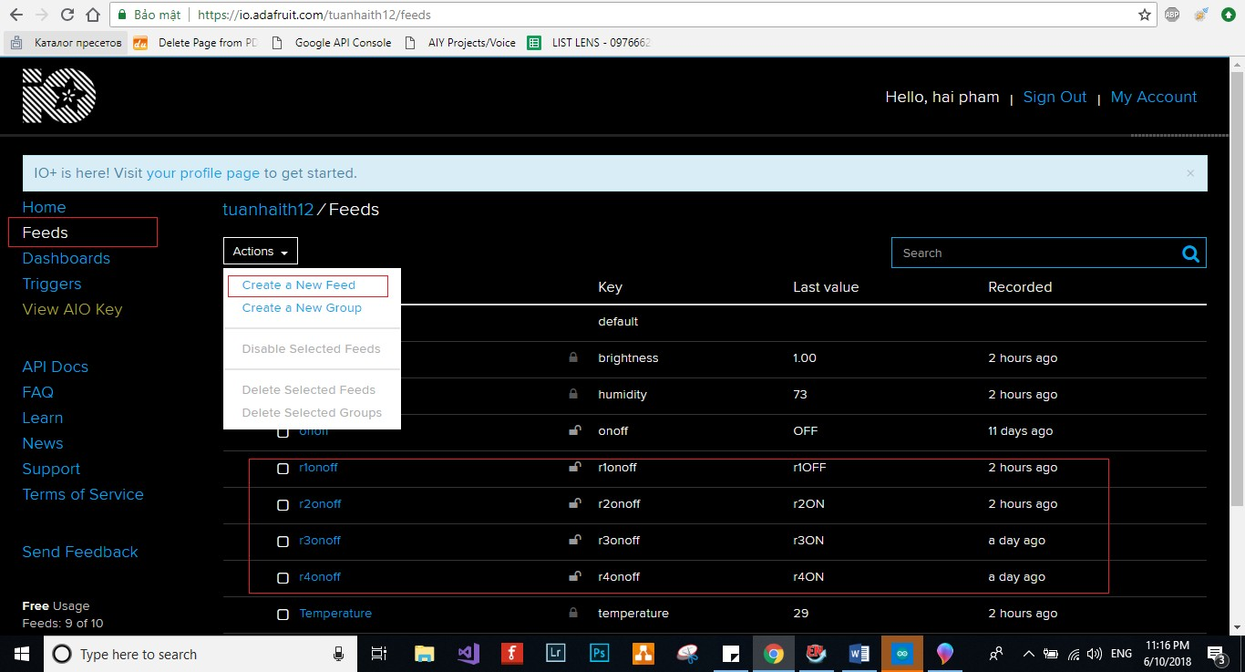

*Figure 22. Create Feeds on Adafruit io.*

# The Dashboards tab:

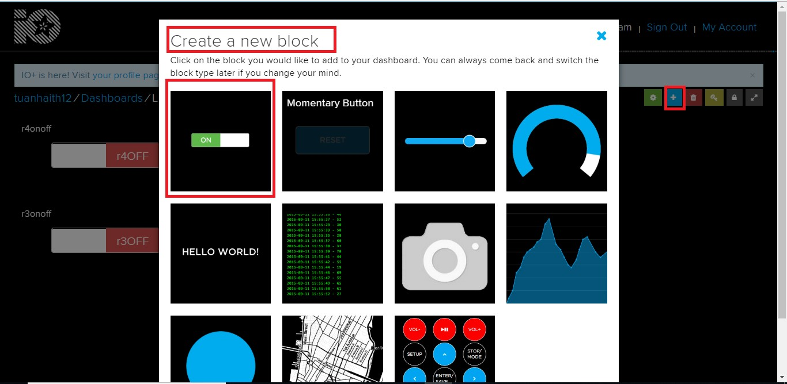Now, I click on the Actions drop-down menu, and create a new dashboard "LightSwitch".

*Figure 23. Steps to create dashboard.*

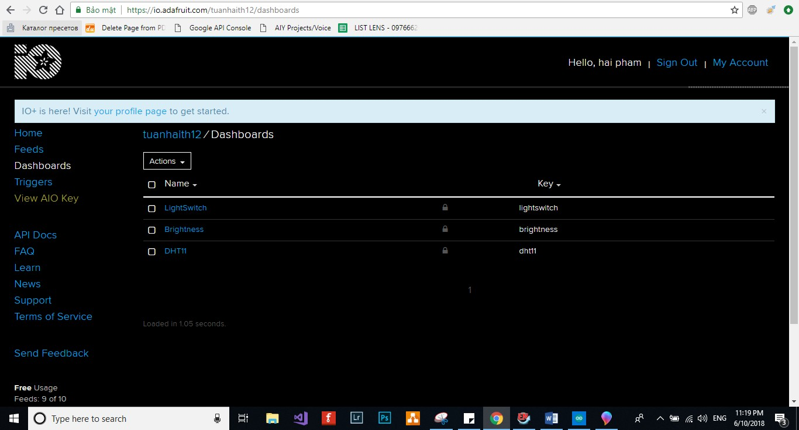

*Figure 24: The Dashboard created.*

Library:



These are the settings for connecting to the Adafruit IO Account in Figure 25.

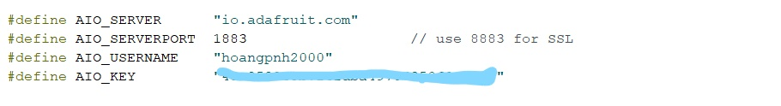*Figure 25. The AIO KEY for adafruit-io connected.*

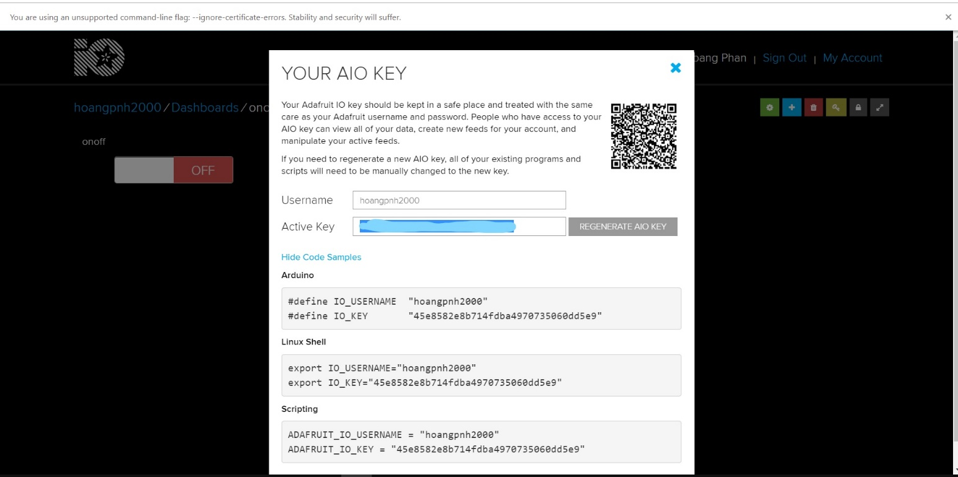

I create the WiFiClient and Adafruit_MQTT_Client objects as global variables on the following code.



In the setup:

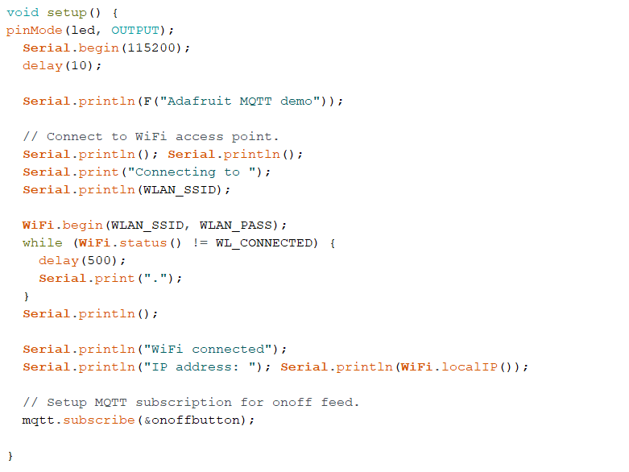

In the loop():

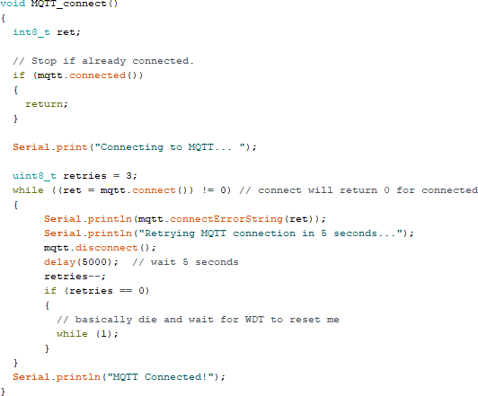Using the function to connect the mqtt cloud

Read from our subscription queue until we run out, or wait up to 5 seconds for subscription to update.

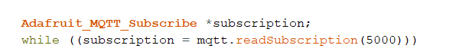

If we are in here, a subscription updated...

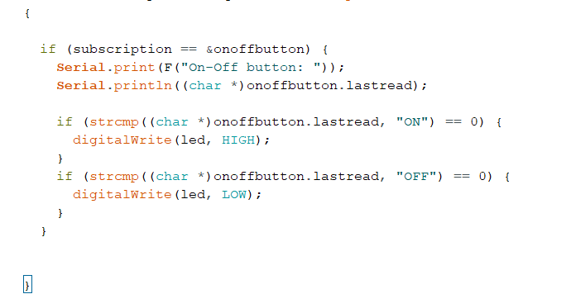

More detail… visit to Github:

* + 1. IFTTT

IFTTT stands for If This Then That, [30], which is a free platform that helps increase the customization on all your applications and devices. It derives its name from the programming conditional statement “if this, then that.” The company provides a software platform that connects applications, devices, and services from different developers to enable one or more automated features related to these applications, devices, and services. Connecting Google Assistant to Adafruit IO MQTT Broker enables the light control through voice command. To do this, the use IFTTT platform allows hundreds of different services to trigger actions in other services.

After setting up the account and taken a look around, go to the Maker's Platform to start making your own applets.

The instruction to install IFTTT on website could be find on this link[1]:

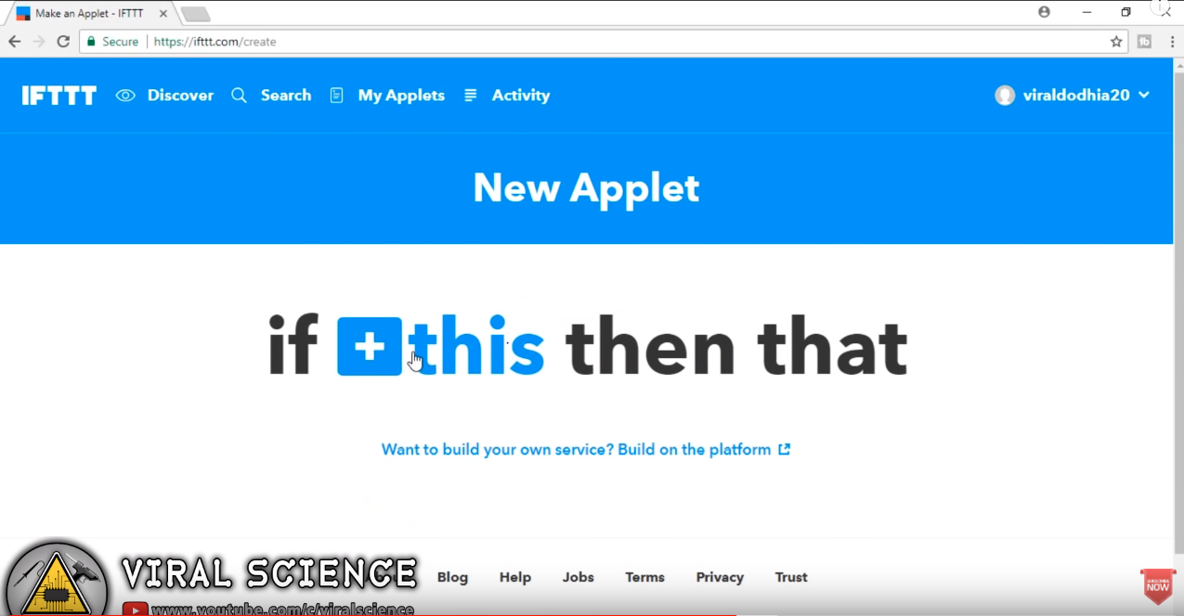

Figure 1 Example on the website

Another way to install IFTTT on smart devices[2]:

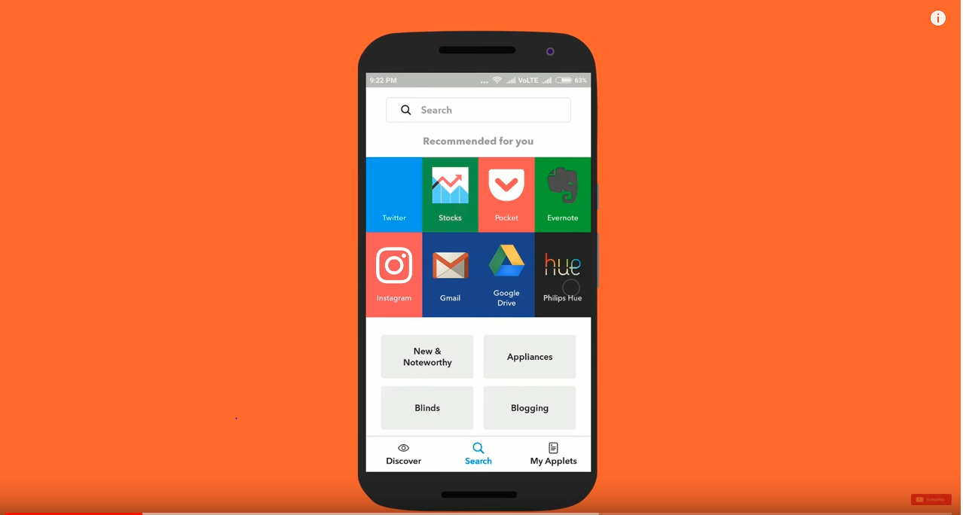

Figure 2 Example on smart device

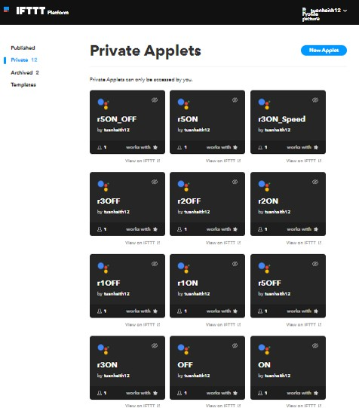

*Figure 26: IFTTT’s applet.*

For the applet shown in Figure 26, this play a role that will analyze the command through these applets and send the message to the cloud database.

**CHAPTER 2 : RESULT**

1. CASE 1 ( LIGHT 1 )

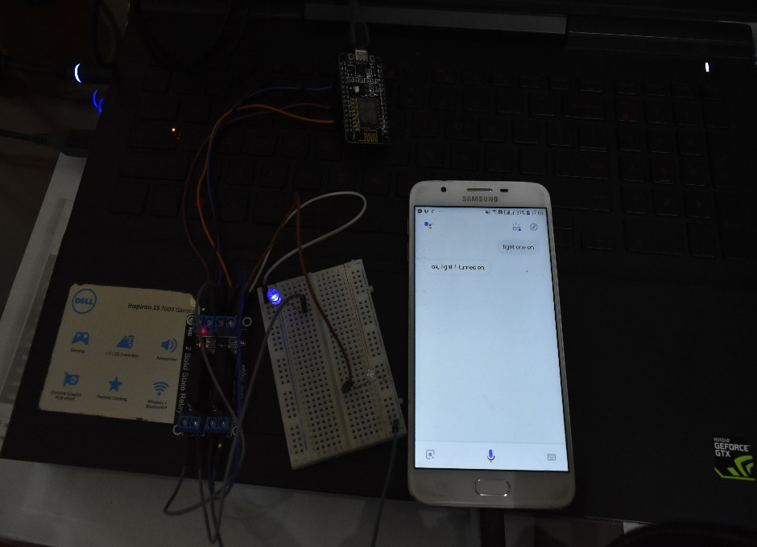

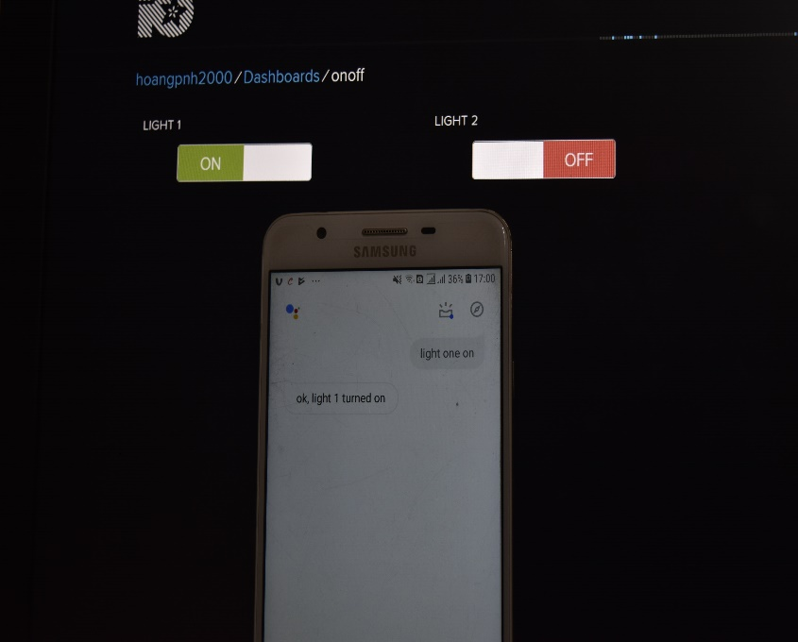

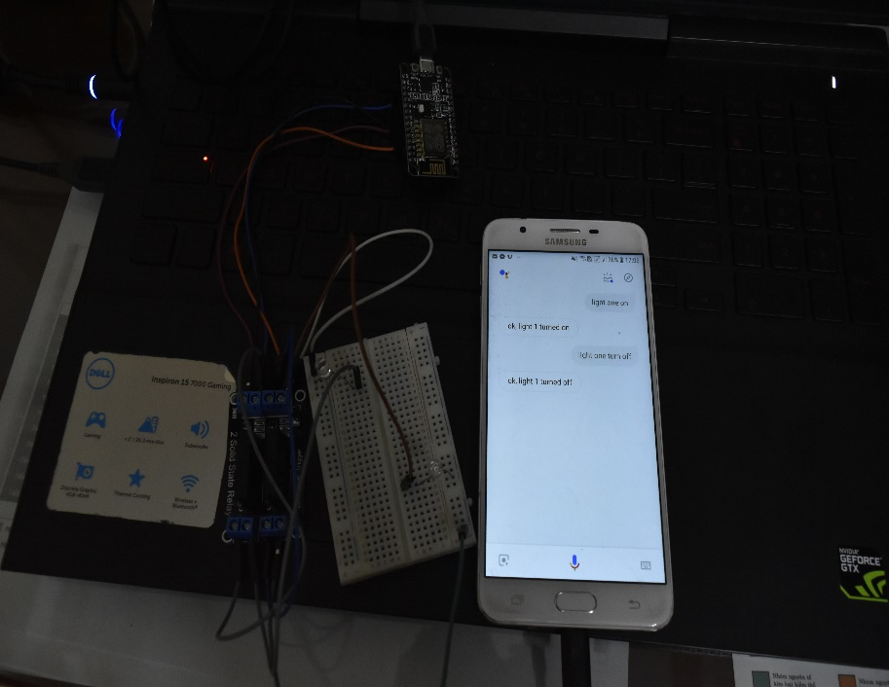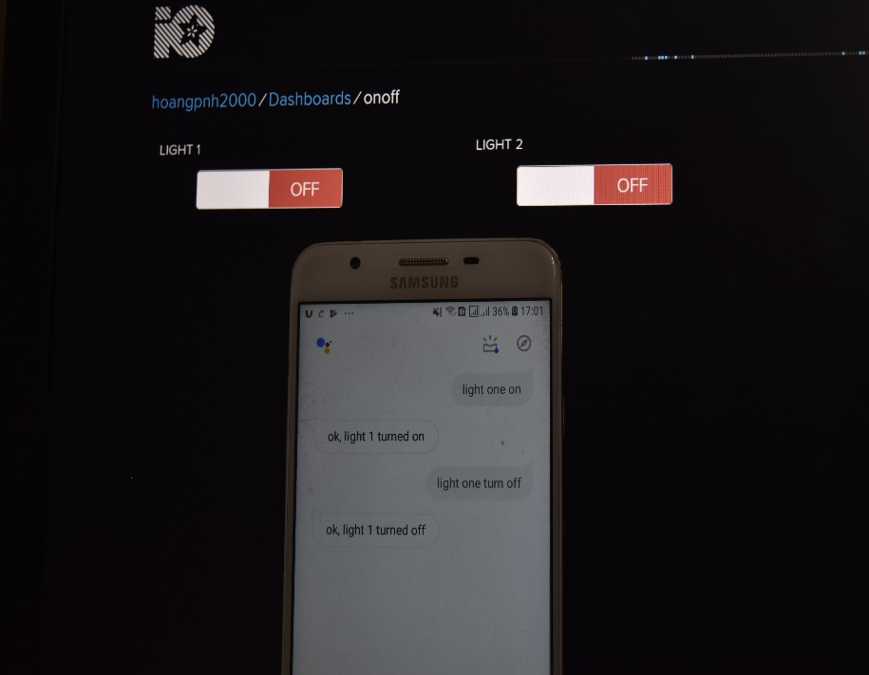 Light 1 ON

Light 1 OFF

1. 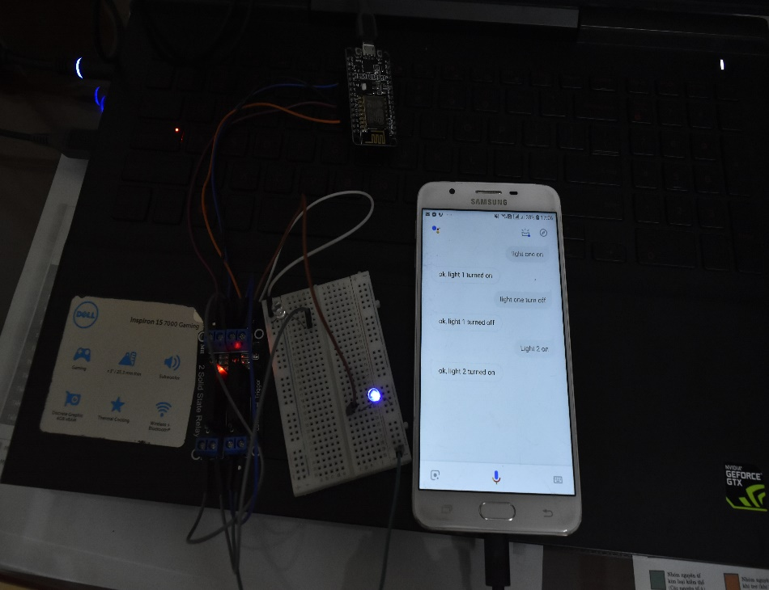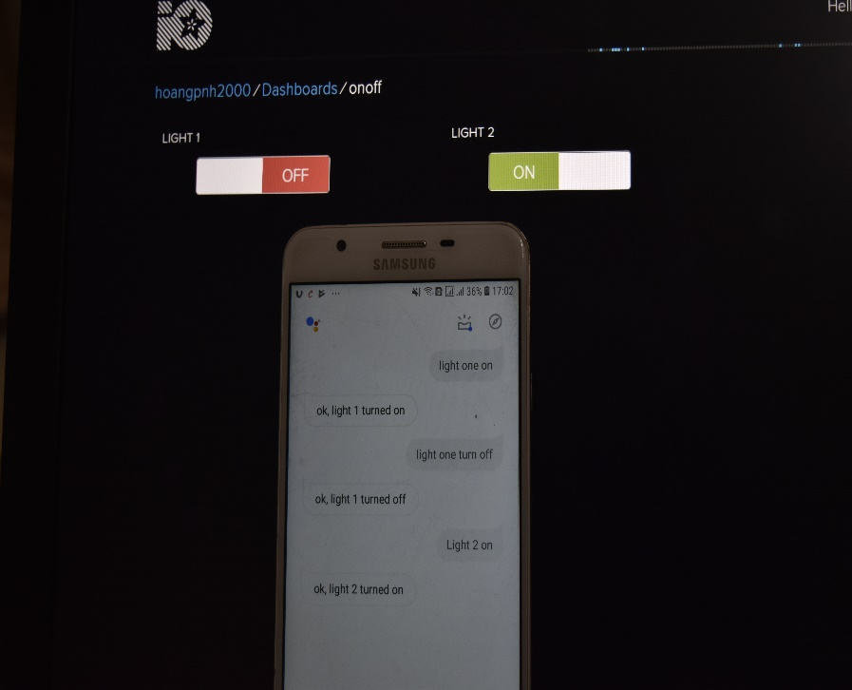CASE 2 ( LIGHT 2 )

Light 2 ON

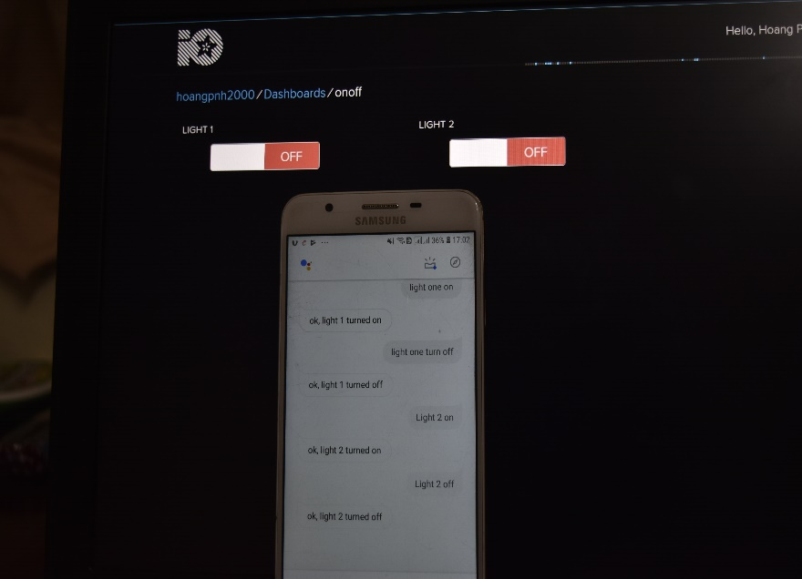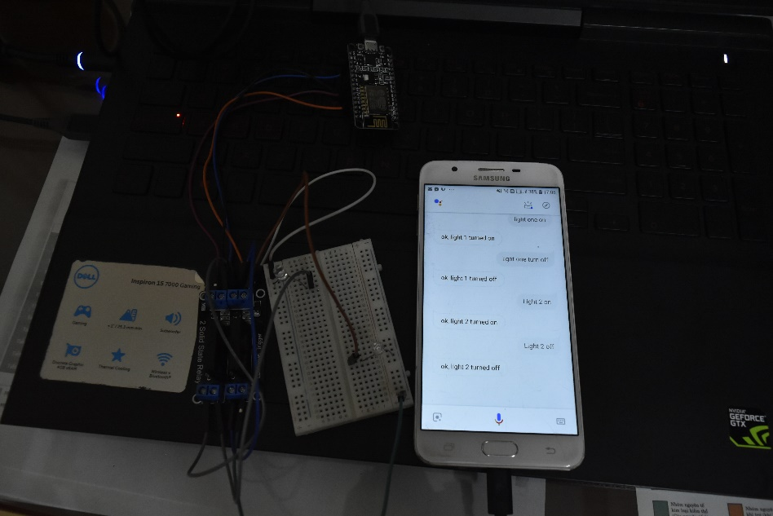

Light 2 OFF

1. <https://www.youtube.com/watch?v=1goTMGq26wE&feature=youtu.be&fbclid=IwAR1eJKIVbdNo1Ef51KyAMYoI2IxIv2V6N0nXP3uxToFCfVmiyiFDOX9_G6E> [accessed 17/12/2018]
2. <https://www.youtube.com/watch?v=DJ2ZHAQhAqc> [accessed 17/12/2018]